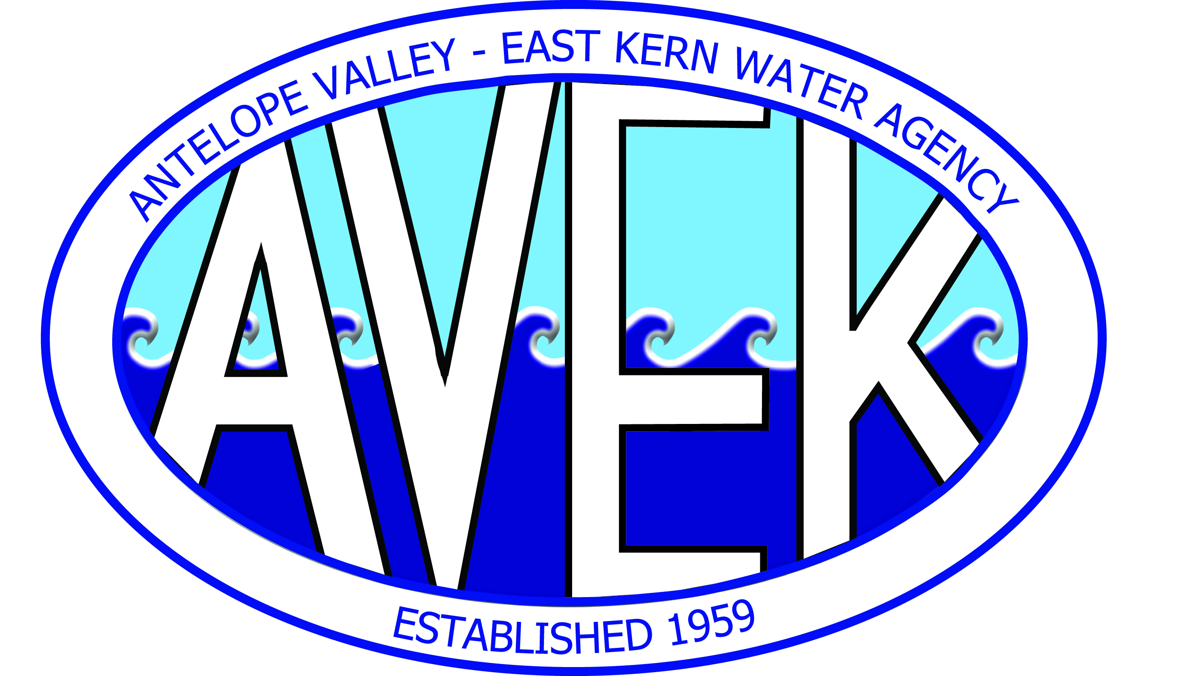
`

ANTELOPE VALLEY-EAST KERN WATER AGENCY
ANTELOPE VALLEY-EAST KERN WATER AGENCY FINANCING AUTHORITY
REGULAR BOARD MEETING AGENDA
TUESDAY, OCTOBER 28, 2025, AT 5:30 PM
6450 WEST AVENUE “N,” PALMDALE, CA 93551
TELECONFERENCE LOCATION(S): 2856 Owens Way, Rosamond, CA 93560; 2020 Highland Way, Mitchell, SD 57301 & ZOOM

Teleconference: (669) 900-6833; ID No. 894 3572 7657#; PASSCODE: 0
Video Conference: https://us02web.zoom.us/j/89435727657?pwd=ak1XbmprdFBUQnRZOWszWU91VHdyUT09
**Please mute audio at all times unless speaking**

- CALL TO ORDER
- PLEDGE OF ALLEGIANCE
- ROLL CALL: Division 6 – Audrey Miller _____; Division 5 – Robert Parris _____; Division 3 – Jay Tremblay _____; Division 2 – Keith Dyas _____; Division 1 – Drew Mercy _____; Division 7 – Gary Van Dam_____; Division 4 – George Lane _____

OFFICERS: General Manager – Matthew Knudson; Attorney – Jim Markman/Tilden Kim; Board Secretary/Treasurer – Holly Hughes

- VOLUNTARY PUBLIC ROLL-CALL – If any member of the public wishes to introduce themselves, please feel free to do so now.

- PUBLIC COMMENTS AND PERIOD OPEN TO THE PUBLIC – If anyone wishes to address the board on any item not on the agenda, please feel free to do so now.

- ADOPTION OF AGENDA
Page
6(a-1) | Adoption of Agenda for Regular Board Meeting of October 28, 2025 | Board Order 6(a-1)

- CONSENT CALENDAR – ACTION ITEMS – The public and board shall have an opportunity to comment on any action item(s) on the Consent Calendar as the Consent Calendar is considered collectively by the Board of Directors prior to action being taken. Page
7(a-1) | Approve Minutes of the Regular Board Meeting of September 23, 2025 | Board Order 7(a-1)
- ITEM(S) FOR CONSIDERATION AND POSSIBLE ACTION
a. New Business / Presentation Page
8(a-1) | Presentation on Property Tax Analysis and Forecast Report – Dave Schey, HdL Coren & Cone (Information Only)
b. Finance Committee (KD/GL/RP) 10/23/25 Page
8(b-1) | Consideration and possible action to accept and file the Check Register Lists for the period of October 2, 2025, through October 15, 2025 (General Manager Knudson) | Board Order 8(b-1)
8(b-2) | Consideration and possible action to accept and file the Treasurer’s Report for the month ending September 30, 2025 (Finance Manager Yates) | Board Order 8(b-2)
8(b-3) | Consideration and possible action to approve a Purchase Order with ERS Industrial Services to perform the annual channel cleaning at the Quartz Hill Water Treatment Plant in the not-to-exceed amount of $27,540.00; Budgeted (Operations Manager Bozigian) | Board Order 8(b-3)
8(b-4) | Consideration and possible action to approve a Purchase Order with R&B Automation to remove and replace the 30-inch flow control valve at PRS-1 in the not-to-exceed amount of $52,765.86; Budgeted (Operation Manager Bozigian) | Board Order 8(b-4)
c. Planning & AVSWCA Committee (KD/GV/DM) 10/09/25 Page
8(c-1) | Consideration and possible action to approve Resolution R-25-25; Approving the Antelope Valley State Water Contractors Association (AVSWCA) budget for the 2025/2026 United States Geological Survey (USGS) Groundwater Monitoring Program; AVEK’s share in the amount of $32,744.00 (Assistant General Manager Thompson) | Board Order 8(c-1)

- GENERAL MANAGER’S REPORT ON WATER SUPPLY, PROJECTS, AND PROGRAMS
- DIRECTORS REPORTS
- ATTORNEY REPORT
- REQUEST FOR FUTURE AGENDA ITEMS
- ADJOURNMENT
Note: The Board reserves the right to discuss and/or act on all the above agenda items.
NOTICES
Any person may make a request for a disability-related modification or accommodation needed for that person to be able to participate in the public meeting by telephoning (661) 943-3201 or writing to Antelope Valley-East Kern Water Agency at 6450 West Avenue N, Palmdale, CA 93551. Requests must specify the nature of the disability, and the type of accommodation requested. A telephone number or other contact information should be included so that Agency staff may discuss appropriate arrangements. Persons requesting disability-related accommodation should make the request with adequate time before the meeting for the Agency to provide the requested accommodation.

A complete agenda packet containing all accompanying reports for this agenda is available by contacting the Board Secretary-Treasurer at hhughes@avek.org or (661) 943-3201, or at the Antelope Valley-East Kern Water Agency, 6450 West Avenue N, Palmdale, CA 93551. Board meetings are subject to audio recording.

Posted: October 23, 2025 @ 12:00 pm by Angel Fitzpatrick, Executive Assistant

